**ED KIIRU**

**IPBC – Mortgage R1:SP3: Story 4**

Created a new Database

Created a new table for normalized datset

Verified table is up and running

Created the view to be used in loading the different tables

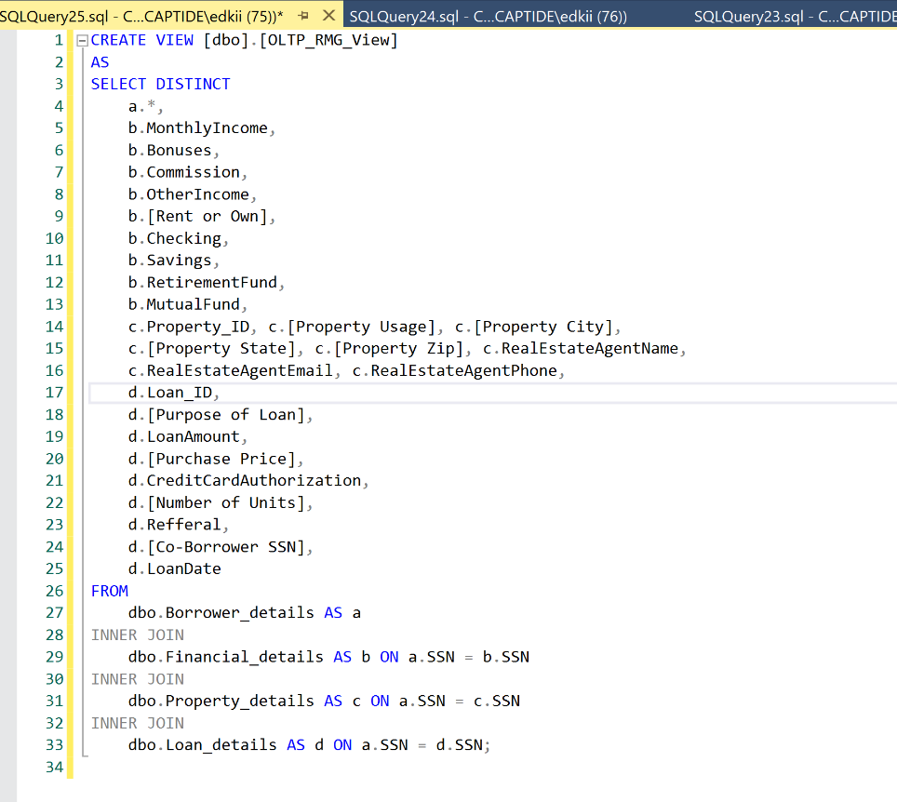

Created a new package for data verification starting with a data flow task

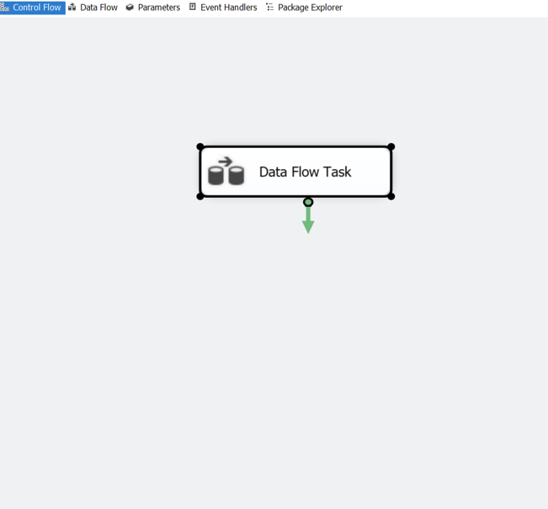

Created the OLE DB Source and started configuring it

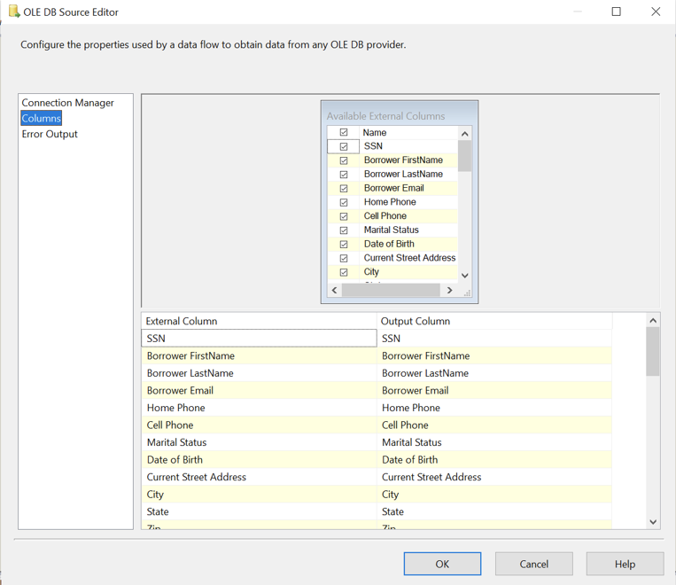

Configured the OLE DB connection to work with a view

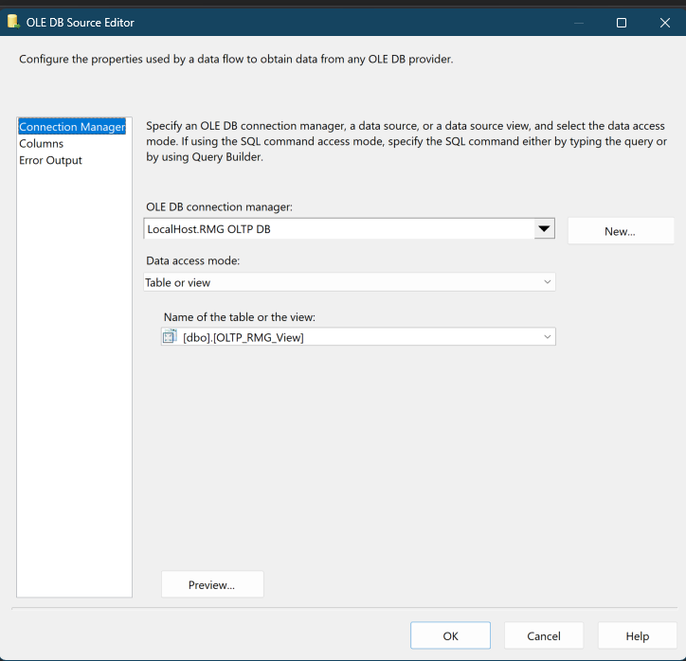

Configured the OLEDB source editor

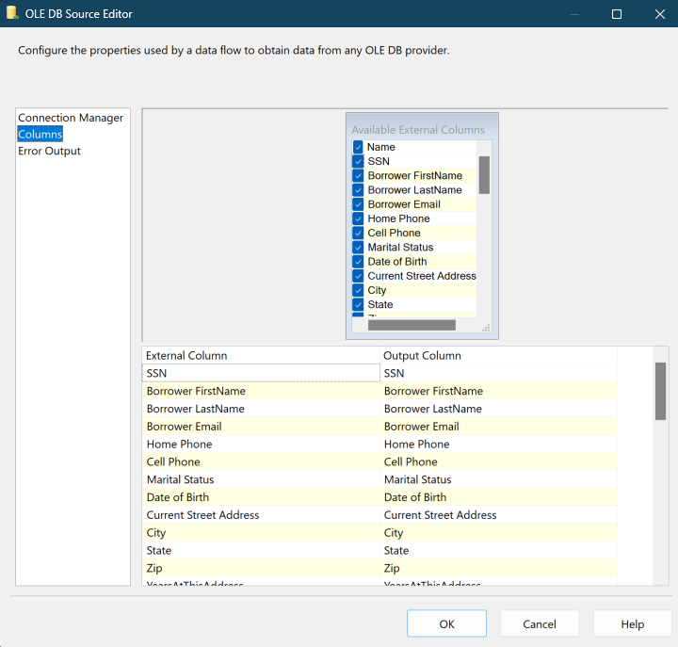

Configured the conditional split

Mapped the data conversion transformation

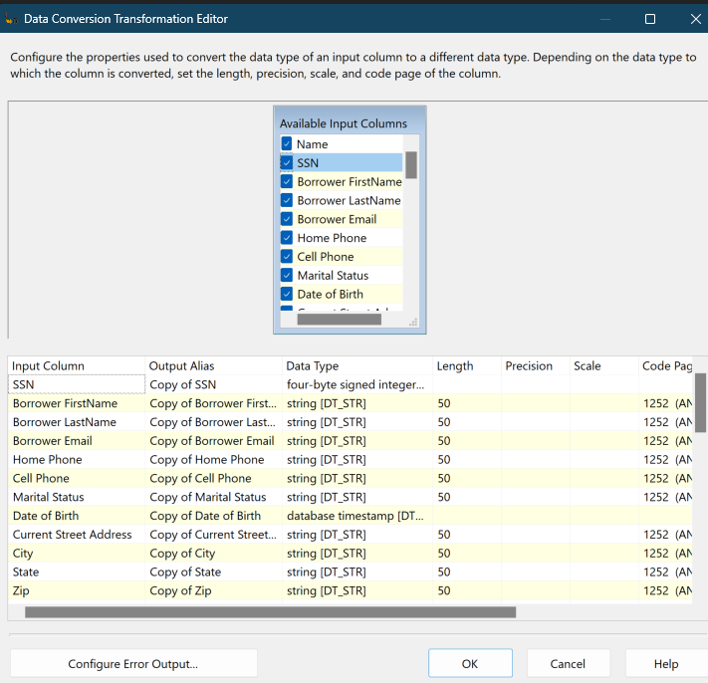

Configure the OLE DB Destination and created the connection manager

Created Flat File Destination as Txt log files for error that will be pullout from the condition in our conditional split

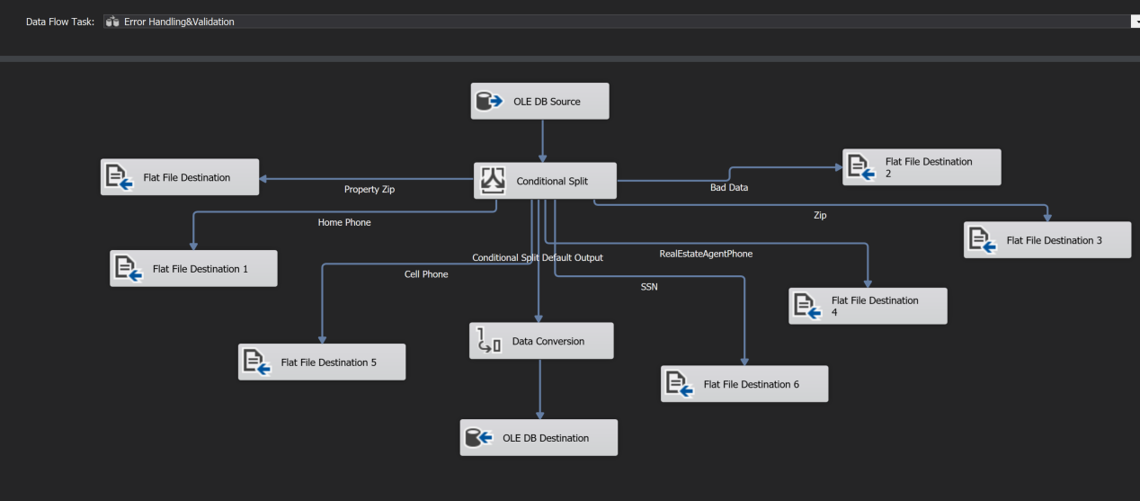

Executed the package, all went through with row getting to the destination table and 3 going to the error log flat file on property zip errors

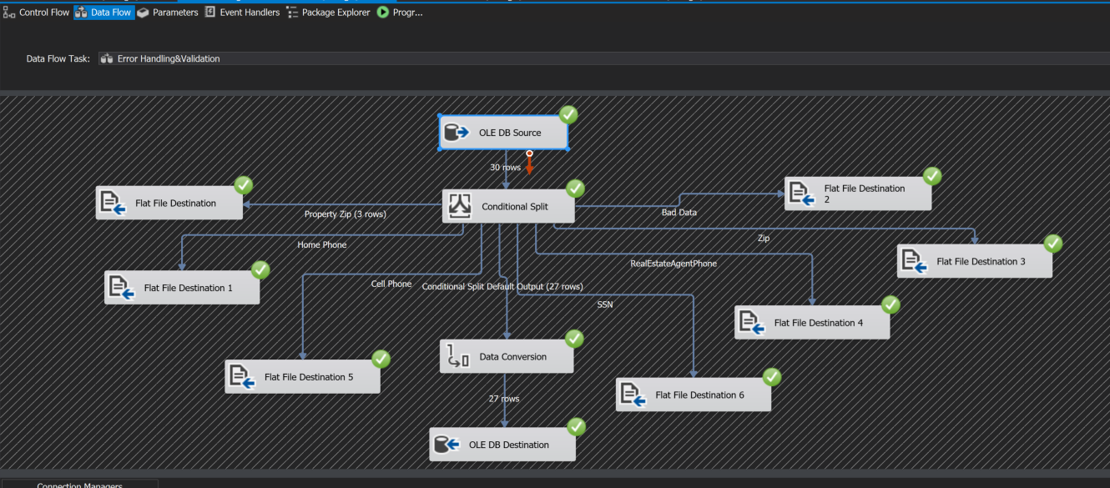

Verified the Files were laded to the destination table

Error data from the error log flatfile

